Global Landslide Catalog Project

For this project, we created plots with data from the Global Landslide Catalog to visualize the distribution of landslides across the world and show their most common causes. We will also look at which regions have more destructive/deadly landslides.

Map showing the distubution of landslides recorded in this dataset

## Dataset Columns:

Dates/Time: event_date / event_time / month

Scale

landslide_size converted to landslide_size_num /

fatality_count / injury_count

Location

Longitude / latitude

**Other Information:**

landslide_category /landslide_trigger /

landslide_setting /country_name / storm_name

# Plots:

**landslide_injuries |** **fatality_count**

**r value: 0.11674872630789888**

There was no correlation between injuries and fatalities. This would seem to be because the dataset isn’t recording all injuries, since more landslides in this dataset have recorded fatalities than injuries.

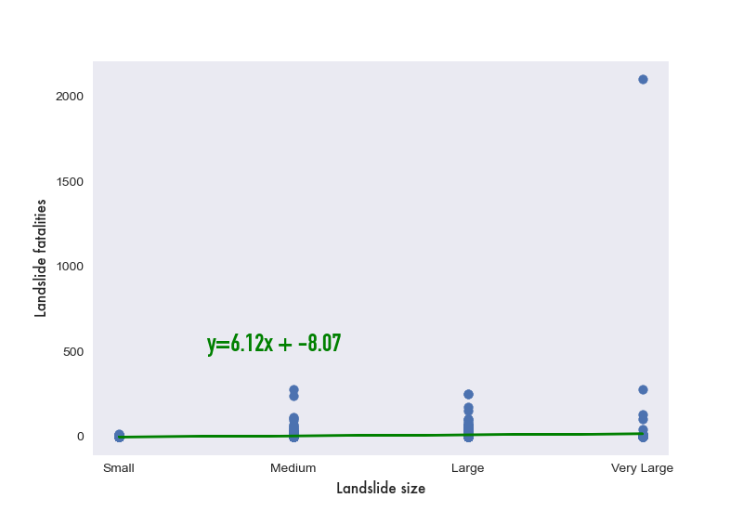

**landslide_size |** **fatality_count**

r value: 0.11674872630789888

There was no correlation between Landslide size and fatalities. This might be because landslide size isn’t measured in very precise terms.

Tracking Monthly/Seasonal Changes – month

This shows which time of the year landslides are most common in the top three countries represented in the dataset.

Comparing Countries - country_name

This chart shows the average number of fatalities per landslide of some of the most well represented countries in the dataset.

Comparing Landslide Causes - landslide_trigger

Pie chart showing the most common causes of landslides

Map of landslide fatalities - fatality_count

# Conclusion:

Because of the nature of the dataset,, we were unable to find any correlations to get further insights about landslides around the world. Instead, we looked at finding ways to visualize the global landslide data and show interesting trends and statistics.